Practical 1

Definition : Load a CSV File using Pandas and Display Summary statistics including Mean, Min, Max, and Standard Deviation.
Outcomes / Learning : The Experiment successfully Calculated The Key statistical Measures for a DataSet, Providing a Clear Summary of The Data’s Central Tendency and Dispersion.
Required Tool : The Experiment was performed using a Python Environment using Pandas Library, a Standard tool for Data Analysis.

Working : The Process involved reading a CSV File into a Pandas Data Frame and using a Built-in Methods like .mean(), .median(), and .std() to Quickly calculate and Display the Desired Statistics.
Step 1 : The Initial Step involves Importing The Pandas, and Then The file is Then loaded into a Pandas Data Frame.
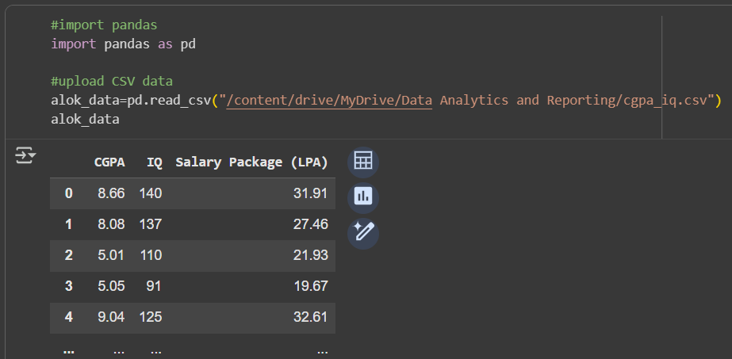
Step 2 : The Data frame Structure is Examined and Summarized using .head() & .shape() Function.
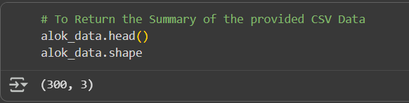
Step 3 : The Maximum Value is found using the .max() Function.
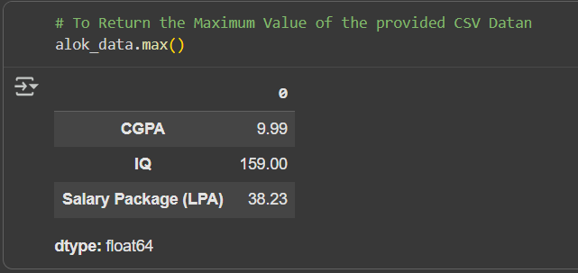
Step 4 : The Minimum Value is found using the .min() Function.
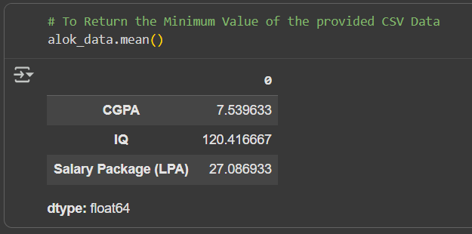

Step 5 : The Average Value if found using the .mean() Function.
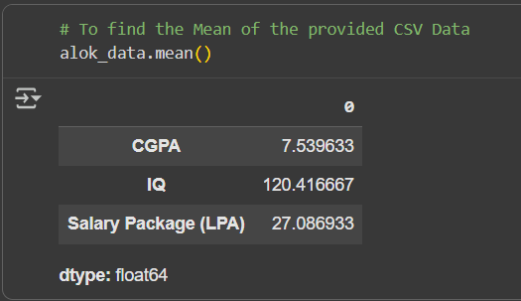

Step 6 : The Middle Value if found using the .median() Function.
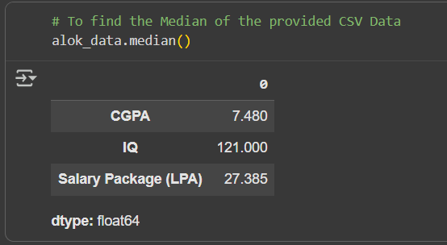
Step 7 : The Most Frequent Value is found using the .mode() Function.
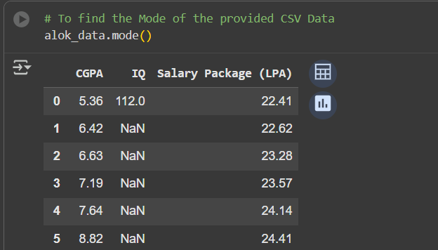

Step 8 : The Measure of The Standard Dispersion if determined using .std() Function.
